NEXUS PLAY
Architecture & Technology Stack — Complete Specification (v2)

0. Platform Overview
NEXUS Play is a premium, cross-platform media streaming application platform designed to work seamlessly on Mobile (Android, iOS) and Web browsers. The platform uses a modern microservices architecture with real-time communication capabilities.

1. Geographic Coverage
Regional Support: Andhra Pradesh (AP), Telangana, National Capital Region (NCR/Delhi)
Comprehensive Coverage: Includes all places, states, and districts within the supported regions.

2. Content Types & Management
The platform supports the following content categories, managed through the Super Admin console and organized by genre, category, and region:
- Movies
- Reels
- Trailers
- Devotional Programs
- Temple Programs
- Live Streaming
- News (AP, Telangana, NCR — Regional News with Breaking News Ticker)
- Games
- Geek / Tech Content
- Watch List (user-curated)

3. Geographic Zoning & Distribution
Zone Structure: 26 Zones → 26 Districts
Live Streaming Infrastructure: 280+ Newsreaders launched for live streaming (National Feed)

4. User Roles & Access Control (RBAC)
User Role | Access Level
Super Admins | Full Administrative Access (C.A)
Newsreader (N.F) | RBAC — Role-Based Access Control
End Users | Public or Super Admin Controlled Access

5. System Architecture

5.1 High-Level System Architecture
The system follows a three-tier architecture pattern: a unified frontend layer (mobile and web clients), a Node.js backend service layer, and a database/storage layer, connected through REST APIs and real-time channels (SSE and WebRTC).

5.2 Frontend Layer (Mobile & Web Clients)
Single unified codebase compiled to native mobile packages and optimized web bundles.

Core Technologies:
React Native + Expo (v56): Cross-platform rendering engine for native mobile packages on iOS and Android
React Web: Translates React Native components into standard HTML elements for modern web browsers
Playback & Media: expo-video for local/remote assets with embedded iframe wrappers and custom regex parser helpers for YouTube video streaming formats
State & Navigation: Context API (AuthContext), Axios for REST API calls, and React Navigation for app routing
Responsive Design: Adaptive layouts for all screen sizes — mobile, tablet, and desktop

5.3 Home Screen & UI Components
The Home tab is the primary discovery surface of the app and is built around two key components:

Dynamic Cards (Home Tab)
- Dynamic content cards rendered on the Home tab, organized as horizontally scrollable rails by genre and category (Movies, Reels, Trailers, Devotional, News, Games).
- Data-driven rendering: Card rails are populated dynamically from the backend REST API, so content, ordering, and banners can be changed by Super Admins without an app update.
- Personalization: Card order and "Recommended for You" rails are driven by the AI recommendation engine using watch history, preferences, and trending data (see Section 6).
- Real-time refresh: New releases and live events are pushed to the Home tab via SSE so cards update without a manual refresh.
- Card types: Poster cards, wide banner/hero cards, continue-watching cards with progress bars, and live-badge cards for ongoing streams.

Breaking News Ticker
- A continuously scrolling breaking news ticker displayed on the Home tab and News section, fed in real time by the Newsreader national feed via SSE.
- Implementation note: The ticker is implemented with React Native's Animated API (a looping translateX animation), ensuring identical behavior on iOS, Android, and Web. The legacy HTML <marquee> tag is deprecated in web standards and is not supported in React Native, so it is not used; the Animated-based ticker provides the same visual effect with full cross-platform compatibility.
- Behavior: Ticker items are prioritized by severity (breaking > regional > general), are tappable to open the full news story, and pause on user interaction for accessibility.

5.4 Backend Layer (API & Services)

Framework & Runtime:
Node.js ES6 Modules: JavaScript runtime for server-side execution
Express.js: Lightweight REST API framework for HTTP request handling
Environment — Production Grade: Optimized for scalability and performance

Core Services:
- REST API Server — HTTP request/response handling
- SSE Events Service — Server-Sent Events for real-time notifications, Home-tab card updates, and breaking news ticker feed
- WebRTC Relay — Peer-to-peer communication infrastructure
- Session Management — User authentication and token validation
- Rate Limiting & Caching — Performance optimization

5.5 Database Layer
Component | Details
Primary Database | SQLite with node:sqlite native module
Query Language | SQL for relational data management
Data Storage | User profiles, content metadata, watch history, preferences, news ticker items
Performance | Lightweight, file-based, suitable for embedded scenarios; WAL (Write-Ahead Logging) mode enabled to reduce write-lock contention under concurrent load
Scalability Path | Migration path to PostgreSQL planned if concurrent write volume (watch history, sessions) exceeds SQLite's comfortable limits at 1000+ simultaneous users

5.6 Real-Time Communication Protocol
Technology | Purpose & Details
P2P WebRTC | Peer-to-peer communication for low-latency direct connections
SSE (Server-Sent Events) | Server pushes real-time notifications, offers, answers, ICE candidates, dynamic card updates, and breaking news items
Heartbeat Mechanism | Keeps connections alive and maintains connection status
Stream Playback | Bidirectional streaming with adaptive quality based on bandwidth

5.7 Media & Content Delivery
Local Media Directory: Stores videos locally with AI-based video intelligence (vid)
YouTube Integration: Embedded iframe player for seamless YouTube content playback
Stream Playback Protocol: HLS/DASH for adaptive streaming with multiple quality levels
Content Caching: Local caching for offline viewing and reduced bandwidth usage
CDN Integration: Optional CDN for global content distribution

5.8 System Communication Flow
- Client initiates connection via REST API
- Backend validates credentials and establishes session
- SSE connection established for real-time events (notifications, Home-tab card updates, news ticker)
- WebRTC relay negotiates peer-to-peer connections
- Heartbeats maintain connection stability
- Media streaming begins with adaptive bitrate selection
- User events (play, pause, stop) sent via REST or WebRTC

6. Premium Tiers & Features
Tier | Features
Tier 1–4 | Available for All Users
Personalized Channel | AI-powered recommendations based on viewing history — also drives dynamic card ordering on the Home tab
Content Upload | Parts/Videos uploaded by genres and categories
Personalized Ads | Targeted advertisements for personalized streaming experience

7. Infrastructure Requirements — With Movies

7.1 Storage Capacity Requirements
Component | Capacity | Details
Base Server Capacity | 57.2 GB | Application & System Files
HD Quality (720p) | 5,150 GB | Standard Definition Storage
Full HD (1080p) | 8,500 GB | High Definition Storage
4K Quality | 15,300 GB | Ultra HD Storage with Download Option
Content Library | 20,000+ Movies | Expandable based on requirements
Total Recommended | 50+ TB | Including redundancy & backup

7.2 Bandwidth & Streaming Requirements
Concurrent Users Support: 1000+ simultaneous streams
Bandwidth (HD): 2.5 Mbps per user
Bandwidth (Full HD): 5 Mbps per user
Bandwidth (4K): 15–25 Mbps per user
Peak Hour Capacity: 280+ Newsreaders (National Feed)
Server Uptime: 99.9% availability
Response Time: < 500ms for API calls

8. Implementation Details — Without Movies

8.1 Development Cost Breakdown
Component | Cost (INR) | Details
App Development (Frontend & Backend) | ₹15,00,000 – ₹25,00,000 | React Native, Expo, Node.js, Express
UI/UX Design & Prototyping | ₹3,00,000 – ₹5,00,000 | Professional design system incl. dynamic Home-tab cards & news ticker
Backend Infrastructure Setup | ₹5,00,000 – ₹10,00,000 | Server, SQLite database, WebRTC setup
Real-Time Services (SSE, WebRTC) | ₹2,50,000 – ₹4,50,000 | Real-time communication infrastructure
Personalization & Analytics Engine | ₹3,00,000 – ₹6,00,000 | AI-based recommendations
Testing & QA | ₹2,00,000 – ₹3,50,000 | Functional, performance, security
Deployment & Setup | ₹1,00,000 – ₹2,00,000 | Production environment
TOTAL (Initial Development) | ₹32,50,000 – ₹57,00,000 | Complete app ready

8.2 Monthly Operational Cost
Expense | Cost (INR/Month) | Details
Server/Cloud Hosting | ₹1,50,000 – ₹2,50,000 | Application hosting (Node.js); storage scales up to 50+ TB with full movie library (see Section 7.1)
CDN & Bandwidth | ₹2,00,000 – ₹4,00,000 | Content delivery, streaming bandwidth
Database Management | ₹50,000 – ₹1,00,000 | SQLite backup, maintenance
Development Team (5 members) | ₹4,00,000 – ₹6,00,000 | Backend devs, frontend devs, DevOps
Licensing & Tools | ₹50,000 – ₹1,00,000 | Software licenses, APIs, monitoring
Support & Maintenance | ₹1,00,000 – ₹2,00,000 | Bug fixes, updates, technical support
TOTAL (Monthly Operations) | ₹8,50,000 – ₹14,50,000 | Continuous operation

8.3 Implementation Timeline
Phase | Duration | Activities
Phase 1: Planning & Design | 2–3 weeks | Requirements, architecture, tech stack
Phase 2: Development | 6–8 weeks | React Native frontend (incl. dynamic Home-tab cards & news ticker), Node.js backend, WebRTC setup
Phase 3: Real-Time Integration | 2–3 weeks | SSE, WebRTC, database integration
Phase 4: Testing & QA | 3–4 weeks | End-to-end testing, performance optimization
Phase 5: Deployment | 1–2 weeks | Production setup, app store release
Phase 6: Post-Launch | 2–4 weeks | Monitoring, optimization, user support
TOTAL PROJECT DURATION | 16–24 weeks (4–6 months) | Complete app launch

9. Quick Reference — Complete Overview
Parameter | Details
App Name | NEXUS PLAY
Regions Covered | AP, Telangana, NCR/Delhi (26 Districts)
Content Types | Movies, Reels, Trailers, Devotional, Temple, Live Streaming, News, Games, Geek, Watch List
Platform | iOS (React Native), Android (Expo), Web (React)
Home Screen UI | Dynamic content cards (genre rails, personalized ordering) + real-time Breaking News Ticker
Backend Framework | Node.js + Express.js
Database | SQLite (node:sqlite, WAL mode) with PostgreSQL migration path
Real-Time Protocol | WebRTC P2P + SSE Server-Sent Events
Streaming Protocol | HLS/DASH with adaptive bitrate
Initial Dev Cost | ₹32,50,000 – ₹57,00,000
Monthly Operations | ₹8,50,000 – ₹14,50,000
Project Timeline | 4–6 months (16–24 weeks)
Storage with Movies | 50+ TB (20,000+ movies)
Concurrent Users | 1000+ simultaneous streams
Server Availability | 99.9% uptime
User Roles | Super Admin, Newsreader, Public Users
Premium Tiers | 4 tiers + AI Personalization
Streaming Quality | 360p to 4K with adaptive bitrate
Security | RBAC, TLS/SSL Encryption, Session Management
Key Features | Dynamic Home-tab cards, Breaking News Ticker, real-time notifications, P2P streaming, personalized channels

10. Application Screenshots — Implemented UI
The following screenshots are taken from the working NEXUS Play web build (localhost development environment) and demonstrate the implemented features described in this document, including the dynamic Home-tab cards (Section 5.3), the Breaking News ticker (Section 5.3), the regional news hub, Reels, Live TV with WebRTC broadcasting, and the user profile system.

10.1 Home Tab — Dynamic Cards & Breaking News Ticker
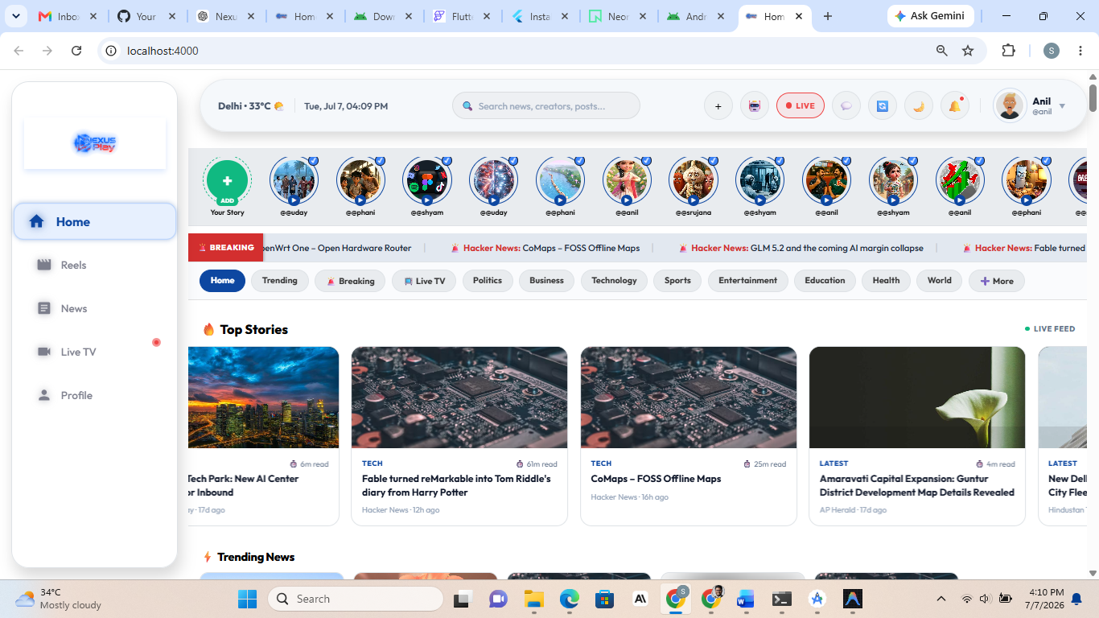
Figure 1: The Home tab showing the dynamic content card rails (Top Stories, Trending News), the creator stories rail, category chips (Politics, Business, Technology, Sports, etc.), and the scrolling Breaking News ticker fed by the live news feed. Card content, ordering, and read-time badges are populated dynamically from the backend API.

10.2 NEXUS Hub — Regional News Feed
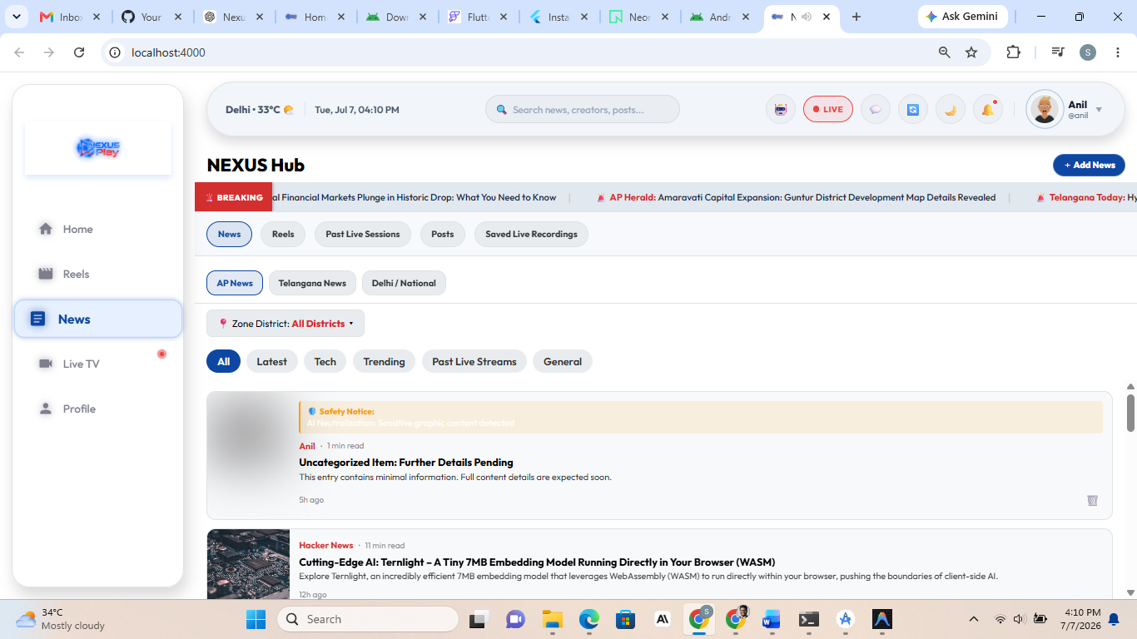
Figure 2: The News section (NEXUS Hub) with region tabs (AP News, Telangana News, Delhi/National), Zone District filter (26 districts), content filters (All, Latest, Tech, Trending, Past Live Streams, General), and the Breaking News ticker. Newsreaders can publish via the '+ Add News' action. An AI safety notice automatically flags and neutralizes sensitive graphic content.

10.3 Reels — Full-Screen Vertical Video Player
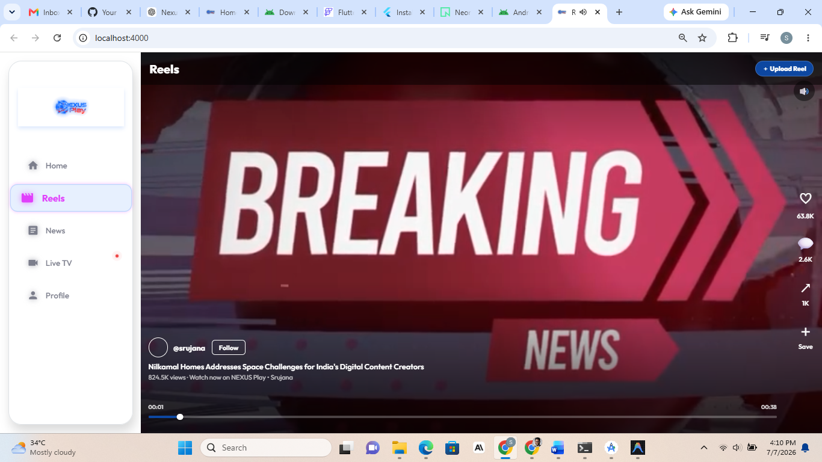
Figure 3: The Reels tab with immersive full-screen playback, creator attribution with Follow action, engagement controls (like, comment, share, save), view counts, playback progress bar, and an 'Upload Reel' action for creators.

10.4 NEXUS Hub — Live Ticker Rotation
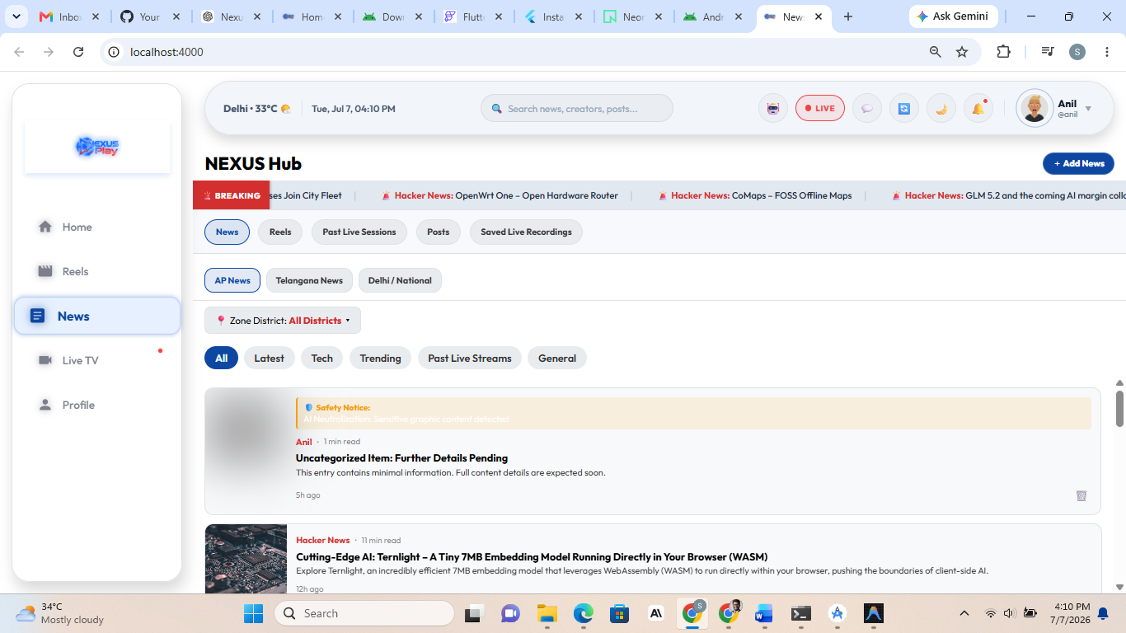
Figure 4: The same News hub showing the Breaking News ticker cycling through live items in real time via SSE — demonstrating that ticker content updates continuously without a page refresh.

10.5 NEXUS Live Explorer
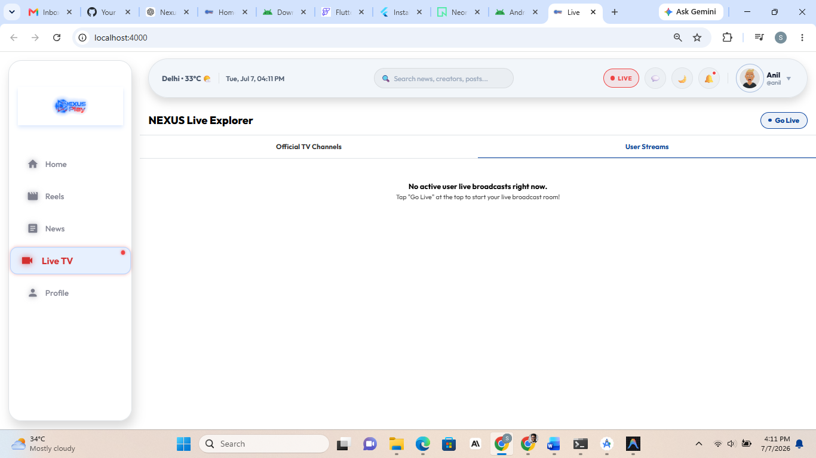
Figure 5: The Live TV section with two tabs — Official TV Channels and User Streams — and a 'Go Live' action allowing users/newsreaders to start their own live broadcast room.

10.6 Live Broadcast Studio (WebRTC)
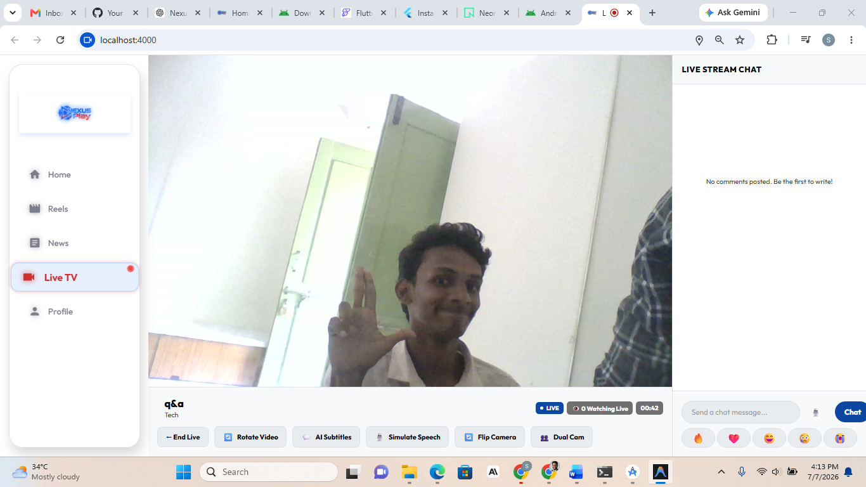
Figure 6: An active user live broadcast powered by the WebRTC infrastructure: live camera feed with elapsed timer and watcher count, real-time Live Stream Chat with emoji reactions, and broadcaster controls — End Live, Rotate Video, AI Subtitles, Simulate Speech, Flip Camera, and Dual Cam.

10.7 User Profile — Overview
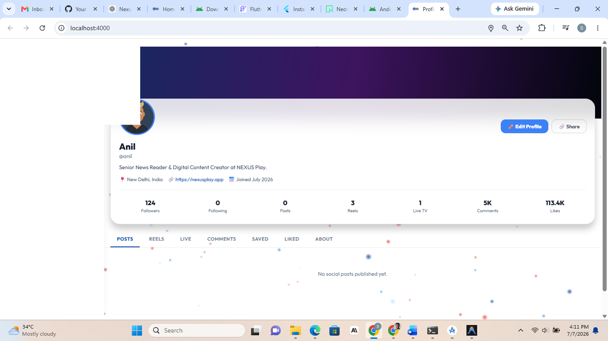
Figure 7: The Profile page with cover banner, avatar, bio, location/website/join-date metadata, and engagement statistics (Followers, Following, Posts, Reels, Live TV sessions, Comments, Likes), plus tabbed navigation: Posts, Reels, Live, Comments, Saved, Liked, About.

10.8 User Profile — Saved Live Recordings
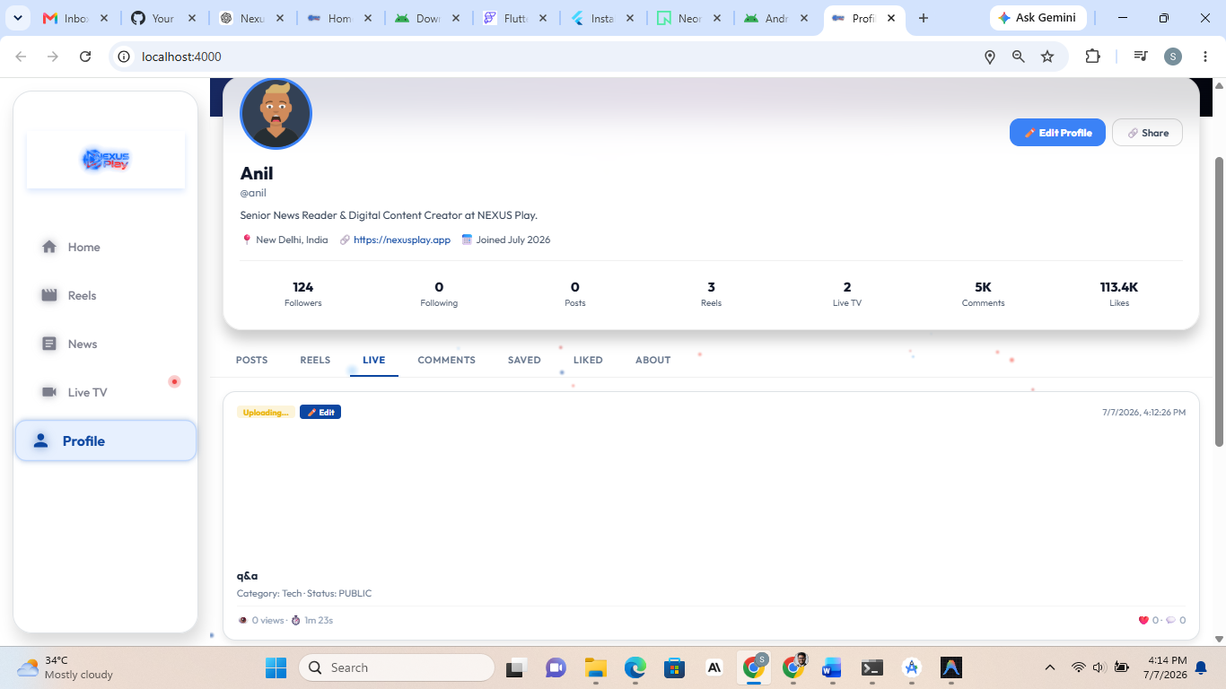
Figure 8: The Live tab on the profile listing past live sessions with title, category, visibility status (PUBLIC), duration, view count, and engagement — recordings are saved and uploaded automatically after a broadcast ends.

10.9 User Profile — About & Account Management
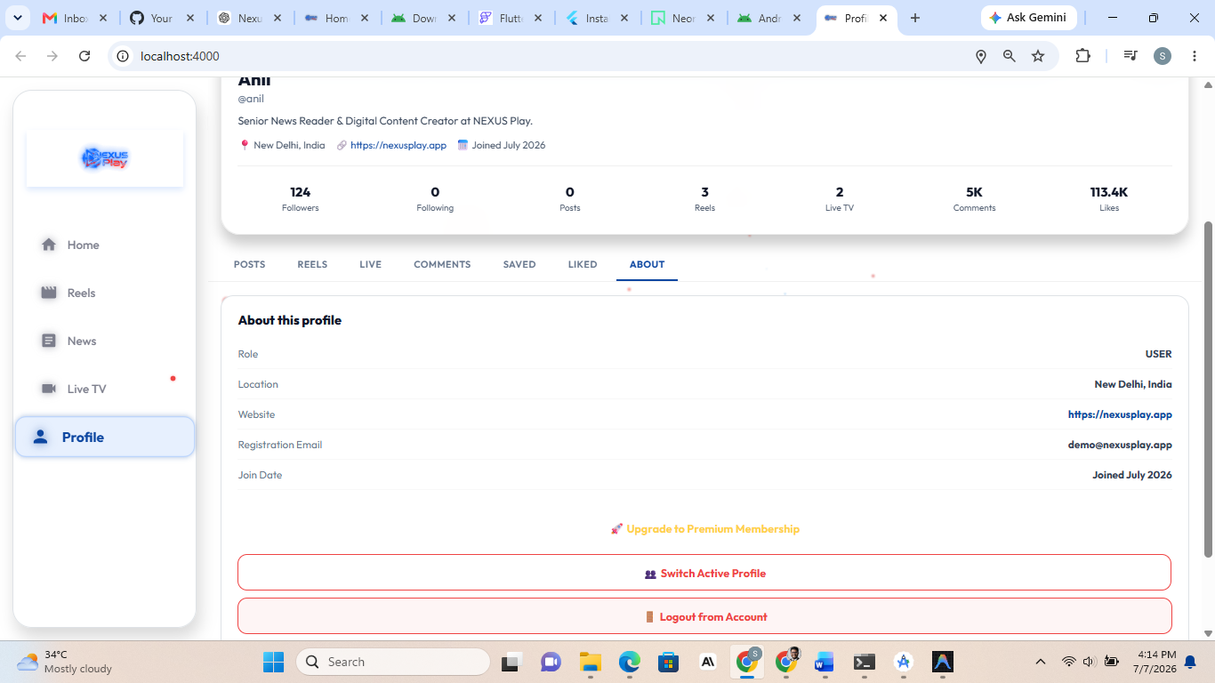
Figure 9: The About tab exposing role (RBAC), location, website, registration email, and join date, along with account actions: Upgrade to Premium Membership (premium tiers), Switch Active Profile, and Logout.

NEXUS PLAY — Complete Architecture & Implementation Specification

